
NORTHERN EDUCATION DIVISION
2026 JUNIOR CERTFCATE MOCK EXAMINANTION
GEOGRAPHY JUNIOR CERTFCATE EXAMINANTION
Provisional marking key
SECTION A (20 MARKS)
Multiple Choice
There are twenty questions in this section. Answer all questions by encircling the letter with the

correct answer. Each question carries 1 mark.
1. A physical map shows the distribution of
- .Lakes, rivers, roads and grass
- .hills. , farms, soils and tress
C. Valleys, plains, hills and mountains
D. Canals, rivers lakes and vegetation’s.
2. Which of the following factors influence the location of industries
A. government policies
B .insecurity.
- Shortage of raw materials.
- political instability

3. The following are atmospheric disasters except
- extreme hot
- volcanic eruption .
- drought.
- Tropical cyclone
4. Which of the following makes the middle section of Shire River good for the generation of electricity.
A. Nearness to industrial sites.
- availability of steep waters.
- .steep gradient.
D. Nearness to homes.
- All the following are the results of a rise in carborndioxide in the atmosphere except.
  - Melting of polar ice cap.
  - Rising of water in the ocean.
  - C .Freezing of Tropical lakes.
  - D. Longer periods of droughts
- Why is the excessive cutting down of trees bad for the hydrological circle?
  - Run off is lowered
  - Transpiration is lowered.
  - Capillary action is increased.
  - Ground water is increased.
- Lines drawn on the synoptic map joining places of same air pressures are called A. Isotherms.
  - Isobars.
  - Isohyets.
  - Contour lines.
- What happens to temperature as one goes higher altitude?
A. Temperature increases
B Temperature decreases.
- Temperature remains constant.
- None of the above

9. Which of the following is not a type of precipitation
A. Drizzles.
- Snow.
- Hail.
- Clouds
`10. A rain gauge should be 30 cm above the ground inorder to
A. Capture more rain drops into it
- prevent evaporation.
- prevent some water splashing into it
D.to prevent it from being covered with soil.
11. Two instruments kept in the Stevensons screen are
A. Thermometers and Hygrometer
B. Thermometers and Sunshine recorder
- Hygrometer and rain gauge.
- wind rose and mercury barometer
12. Which of the following is the direction of the rotation of the earth.
A. South to North.
B .East to West.
- North to South.
- West to east.
- Which of the following are the results of the revolution of the earth.
  - Varying length of day and night
  - Seasonal of the year.
  - deflection of the ocean currents.
  - Day and night.
  - 1 and 2
  - 1 and 3
  - 2 and 4.
  - 3 and 4
- The percentage of oxygen gas in the atmosphere is
  - .0.03
  - 0.09
  - 21
  - 78
- Which of the following is the characteristics of stratosphere.
A. absence of clouds
- positive temperature lapse rate
- vertical movement of wind
- high level of ionization
16. What is the population density of a town with an area of 400 km per square in total with population of 1000000 people?
A. 205 people per square km
- 250 people per square km
- 2500 people per square km
D.25 people per km square
17. What happens when birth rate is higher than death rate?
A .mortality rate declines
- mortality rate increases
- population declines.
- population increases.
- Which of the following processes led to the formation of Lake. Malawi?
  - Down warping
  - Faulting
  - human activity
  - Volcanic activity
- Why cultivation on steep slope is discouraged?
  - infiltration of rain water is difficult
  - Hill slope have poor soil
  - causes siltation in water bodies
  - causes landslide
- Which of the following wildlife reserves is the largest in Malawi
  - Liwonde
  - Majete
  - Nyika
  - Nkhotakota
SECTION B (50 Marks
Answer all questions in this section on the answer sheet provided.
Figure 2 is a map extract for Kasinje. Use it to answer questions that follow
21. a. Give the four figure grid reference for the quarry
8386 (1 mark
- What is the vertical interval of the map?
50m (1mark)
- Identify any two land uses shown on the map
-transport
-settlement
-agriculture/farming
- quarrying
(2 marks)
- (i) In what way has relief been represented on the map.
-through use of contour lines

(1 mark)
(ii) Identify the drainage pattern in four figure grid reference 8590
-dendritic (1 mark)
- Give any two settlement patterns shown on the map
-Scattered/dispersed
-linear
-Nucleated
(2 marks)
- Calculate the bearing of the quarry from the permanent building in Mitongwe Estate
-112 or 113 or 114 degrees
(2 marks)
22. a. Measure the distance of the railway line north of the bridge and give your answer to the nearest kilometer
4.6km nearest 5km (2 marks)
  - Calculate the area covered by Mitongwe Estate (show your working)
Number of full boxes=0
Number of half boxes=8
Area=8/2 boxes times 1square km= 4 square km
(4marks)
  - Reduce the map between Easting’s 81 and 84 and between Northings 87 and 90 by
half its original size. (1 marks)
  - On the new map, show the following:
i.Mitongwe Estate (1 mark)
  - The road (1 mark)
  - The new scale (1 marks) (Use the graph paper provided on page 6) 1:100 000
22. a. Describe any two ways in which transport and communication contribute to the growth of manufacturing industries.
- helps in transporting raw materials and finished products
- communication for advertising the products and services 4marks
b. Describe any one possible way of improving Malawi’s unfavourable balance of trade
- join regional groupings in trade
- Encouraging remittances
- Encouraging Malawians to buy local goods and import less
- Developing tourism industry 1 mark
23. a. With a well labelled diagram describe the formation of convectional
rainfall

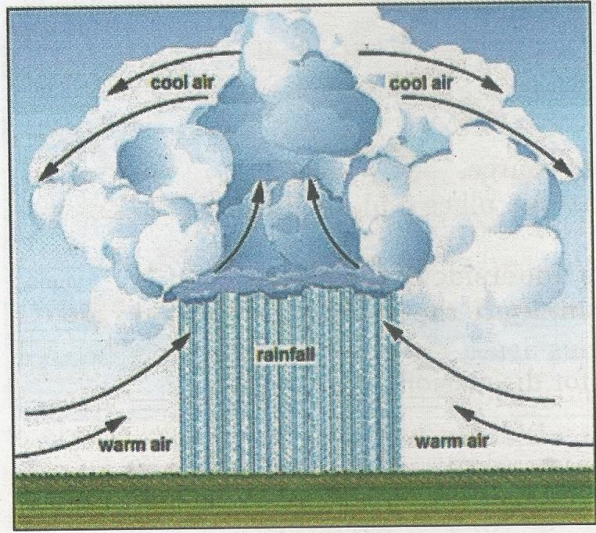
-Formed when sunlight heats the ground and increases surface temperatures; warm air above the ground gets heated as well and rises, it cools and the water vapour condenses to form clouds which produce rain. The colder air in the sky slowly sinks to take the place of rising warm air hence conventional rainfall. 3marks

b. State any two ways in which water can be conserved.
- Turning taps off when not in use
- Promoting water sufficient shower heads and toilets
- Water harvest
- dumping harmful contaminants into toilet
- Growing and maintaining vegetation 2marks
c. Give any two processes of the hydrosphere
- infiltration –percolation –precipitation-run-off-transpiration –evaporation
–condensation
2 marks
d. Qina was tasked to collect temperature readings at a school weather station for six hours from 8:00 AM to 1:00 PM and these were the results:were : 15, 19,30,15, 18 and 17 degrees Celsius respectively. calculate its mean daily temperature? . Show your working.
- mean daily temp = max.temp. + min temp./2
=30degrees Celsius + 15degree Celsius /2
= 22.5 degree Celsius

24. a. Describe any two human activities that can lead to the destruction of natural forest in Malawi.
- Careless cutting down of trees
- Bush fires
- Shifting cultivation 4marks

b. Explain any two ways in which communities living near forests benefit from them.
- Through fresh air from trees
- Trees for construction, firewood
- Food; wild fruits, wild meat 4marks
25. a. a. Describe the following factors that influence tourism in malawi.
i. culture - local traditions, music and food attract visitos
ii. Accommodation – good ones like hotels boost tourism by offering comfort,safety etc
4marks
b. Describe any one factors that may cause fluctuation of lake levels.
- High temperatures leading to high evaporation
- Siltation lowering the depth of lake levels
- High rainfall increasing lake levels 2 marks
c. state any two types of energy resources
- Wind
- Geothermal
- Nuclear
- Solar
- Biomass
- Hydro-electricity 2 marks

SECTION C (30 marks)
Instructions: Question in this section must be answered in the lines provided in an essay form
- Explain any five factors that affect temperature.
  - latitude: places near the equator get more direct sunlight, so they tend to be warmer. As one moves towards the poles, the sun’s rays hit the earth at an angle, resulting in colder temperatures
  - Altitude: the higher you go, the cooler it gets. That is why mountains are often chilly even in summer.
  - Humidity: high amount of water vapour in the atmosphere may led to low temperature than low water vapour
  - Cloud cover :a lot of cloud cover in the atmosphere lowers temperature than little one
  - Distance from the sea : places close to the sea may experience lower temperature during the day than those far away.
15marks
- a. Explain any three ways in which Shire river is important.
  - Production of hydro-electric power
  - Provides source of water for irrigation: at Nchalo sugar company, along Shire river
  - Transport
  - Tourism: wild life reserves are situated along river Shire attracting tourists 6 marks

b. Describe any four examples of natural disasters commonly happen in malawi.
  - Drought; is the prolonged period of no rains. This results into no water supply. As such, loss of lives of animals and people follows.
  - Earthquakes; sudden shaking of the earth’s surface. This results into destruction of the environment, people, animals and buildings. For example, roads
  - Landslides; are the mass movements of rocks, debris, or earth along a sliding plane.
  - Storms or cyclones; strong winds associated with thunder and storm. They bring about
heavy rains which can result into floods. (9marks).

THE END

